|  |  |  |
| --- | --- | --- |
| **Sohag University** | **Transportation planning & Traffic Eng.** | |
| **Faculty of Engineering** | **Level 300** | |
| **Civil Engineering** | **Time: 3 hr.** | |
| **Final Exam (May 2018)** | | |  | |

**Question 1:**

**Explain the following (use sketches to assist your answer):**

|  |  |
| --- | --- |
| * The main stages of the transportation planning process. * Types and functions of traffic control devices. * Conflict points at cross and T intersections. * Capacity and level of service. * O/D Matrix . | * The methods of measuring spot speed. * Clearance-Gap and Spacing-Headway concept. * The methods of trip assignment. * The methods of data collection. * The methods of trip distribution . |



**Question 2:**

* 1. An urban area consisting of four zones has the base –year **O-D** matrix and the future generated trips as shown in the following table. Find the future **O-D** matrix using the **average growth factor** (Do just two iterations)

|  |  |  |  |  |  |
| --- | --- | --- | --- | --- | --- |
| From / To | 1 | 2 | 3 | 4 | Future total |
| 1 | - | 20 | 50 | 15 | 255 |
| 2 | 20 | - | 30 | 5 | 105 |
| 3 | 50 | 30 | - | 40 | 220 |
| 4 | 15 | 5 | 40 | - | 120 |
| Future total | 255 | 105 | 220 | 120 | 700 |

* 1. A calibration effort resulted in the following utility equation:



where: X1= access time in minutes; X2= waiting time in minutes; X3= travel time in minutes; and X4= travel cost in Piaster.

The total trips between two zones equals **6000** person trips per day. The trip makers between these two zones will have a choice between modes A and B, with the following horizon year attributes:

|  |  |  |  |  |
| --- | --- | --- | --- | --- |
| **Variable** | **X1** | **X2** | **X3** | **X4** |
| **Mode A**  **Mode B** | 5  10 | 0  15 | 20  40 | 100  50 |

**I)** Assuming the calibrated mode-specific constants are aA= **-0.12** and aB= **- 0.56**, find the total number of trips between the two zones by each mode.

1. If **aA= 0.44** and **aB=0.00,** Would the results found in part **I** change? Explain.



**Page 1 of 3**

**QUESTION 3:**

**A)** An origin- destination survey in 8 residential travel-analysis zones provided the following data relating to number of population (in hundreds) and daily trip productions.

|  |  |  |  |  |  |  |  |  |
| --- | --- | --- | --- | --- | --- | --- | --- | --- |
| **Trips** | 350 | 450 | 740 | 550 | 400 | 661 | 525 | 700 |
| **Population(100)** | 50 | 105 | 340 | 165 | 120 | 180 | 150 | 300 |

* **Calibrate the relationship .**



* **Calculate the coefficient of determination (R2).**

If the expected population in zone no. eight will be 50000, **calculate the expected no. of trips from this zone in the future.**

**B)**

|  |  |
| --- | --- |
| **Figure 1** | Assign the vehicle trips in the following O-D matrix table to the network shown in Figure 1, using the **all-or-nothing** method. **Complete The two following tables .** |

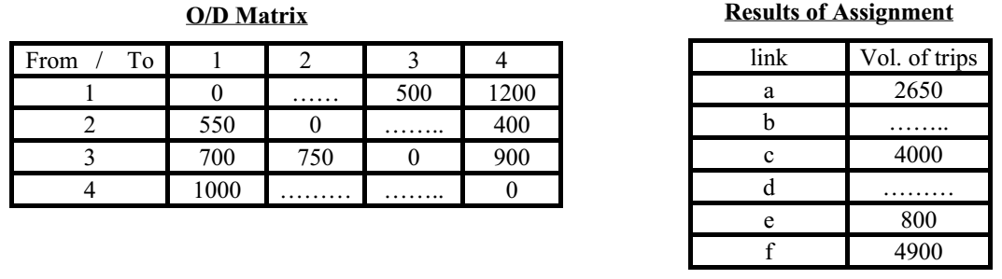



**Question 4:**

**A)** a traffic count was conducted to a rural road ,if the peak hour traffic volume is 4000 veh/day and the directional distribution (40% : 60%) If the traffic composition is 70% p.c & 20% bus(2p.c)& 10% truck(2.5p.c) **Find the number of lanes** ( take capacity =2000 p.c/hr/dir.)



**Page 2 of 3**

**B)** Assuming a linear speed-density relationship, the mean free flow speed is observed to be 90 km/h near zero density and the corresponding jam density is 90 veh./km. Assume that the average length of vehicles is 6m.

* + 1. Write down the speed-density and flow-density equations;
    2. Draw the **v-k**, **v-q**, and **q-k** diagrams indicating critical values;
    3. Compute speed and density corresponding to a flow of **1000** veh /hour; and
    4. Compute the average headway, spacing, clearance, and gap when the flow is maximum.



**QUESTION 5:**

**A)** Find optimum cycle time for four phases traffic intersection with green times: 18 , 24 , 20 , 30 sec. **Using two methods and Comment on solutions** .

**B)** Two highways are intersected at (+) section. The traffic is controlled with traffic signals. The intersection indicates the direction flow and traffic volume (PCU/hr/lane( for each direction as shown in figure. It is required to determine the following:

|  |
| --- |
| * **Traffic signals program** * **The green signal time for different phases** * **The green pedestrian time and** * **Draw the traffic signal results**   **N.B)** Take the saturation flow as **1800**, **1600** and **1500** (Pcu/hr) for longitudinal, right and left directions respectively.  - Pedestrian congestion is (**500** person/10 minutes) and the pedestrian lane width is **5**m. |



**With my best wishes,**

**Associate Prof.Dr.Talaat Ali Ahmed**



**Page 3 of 3**